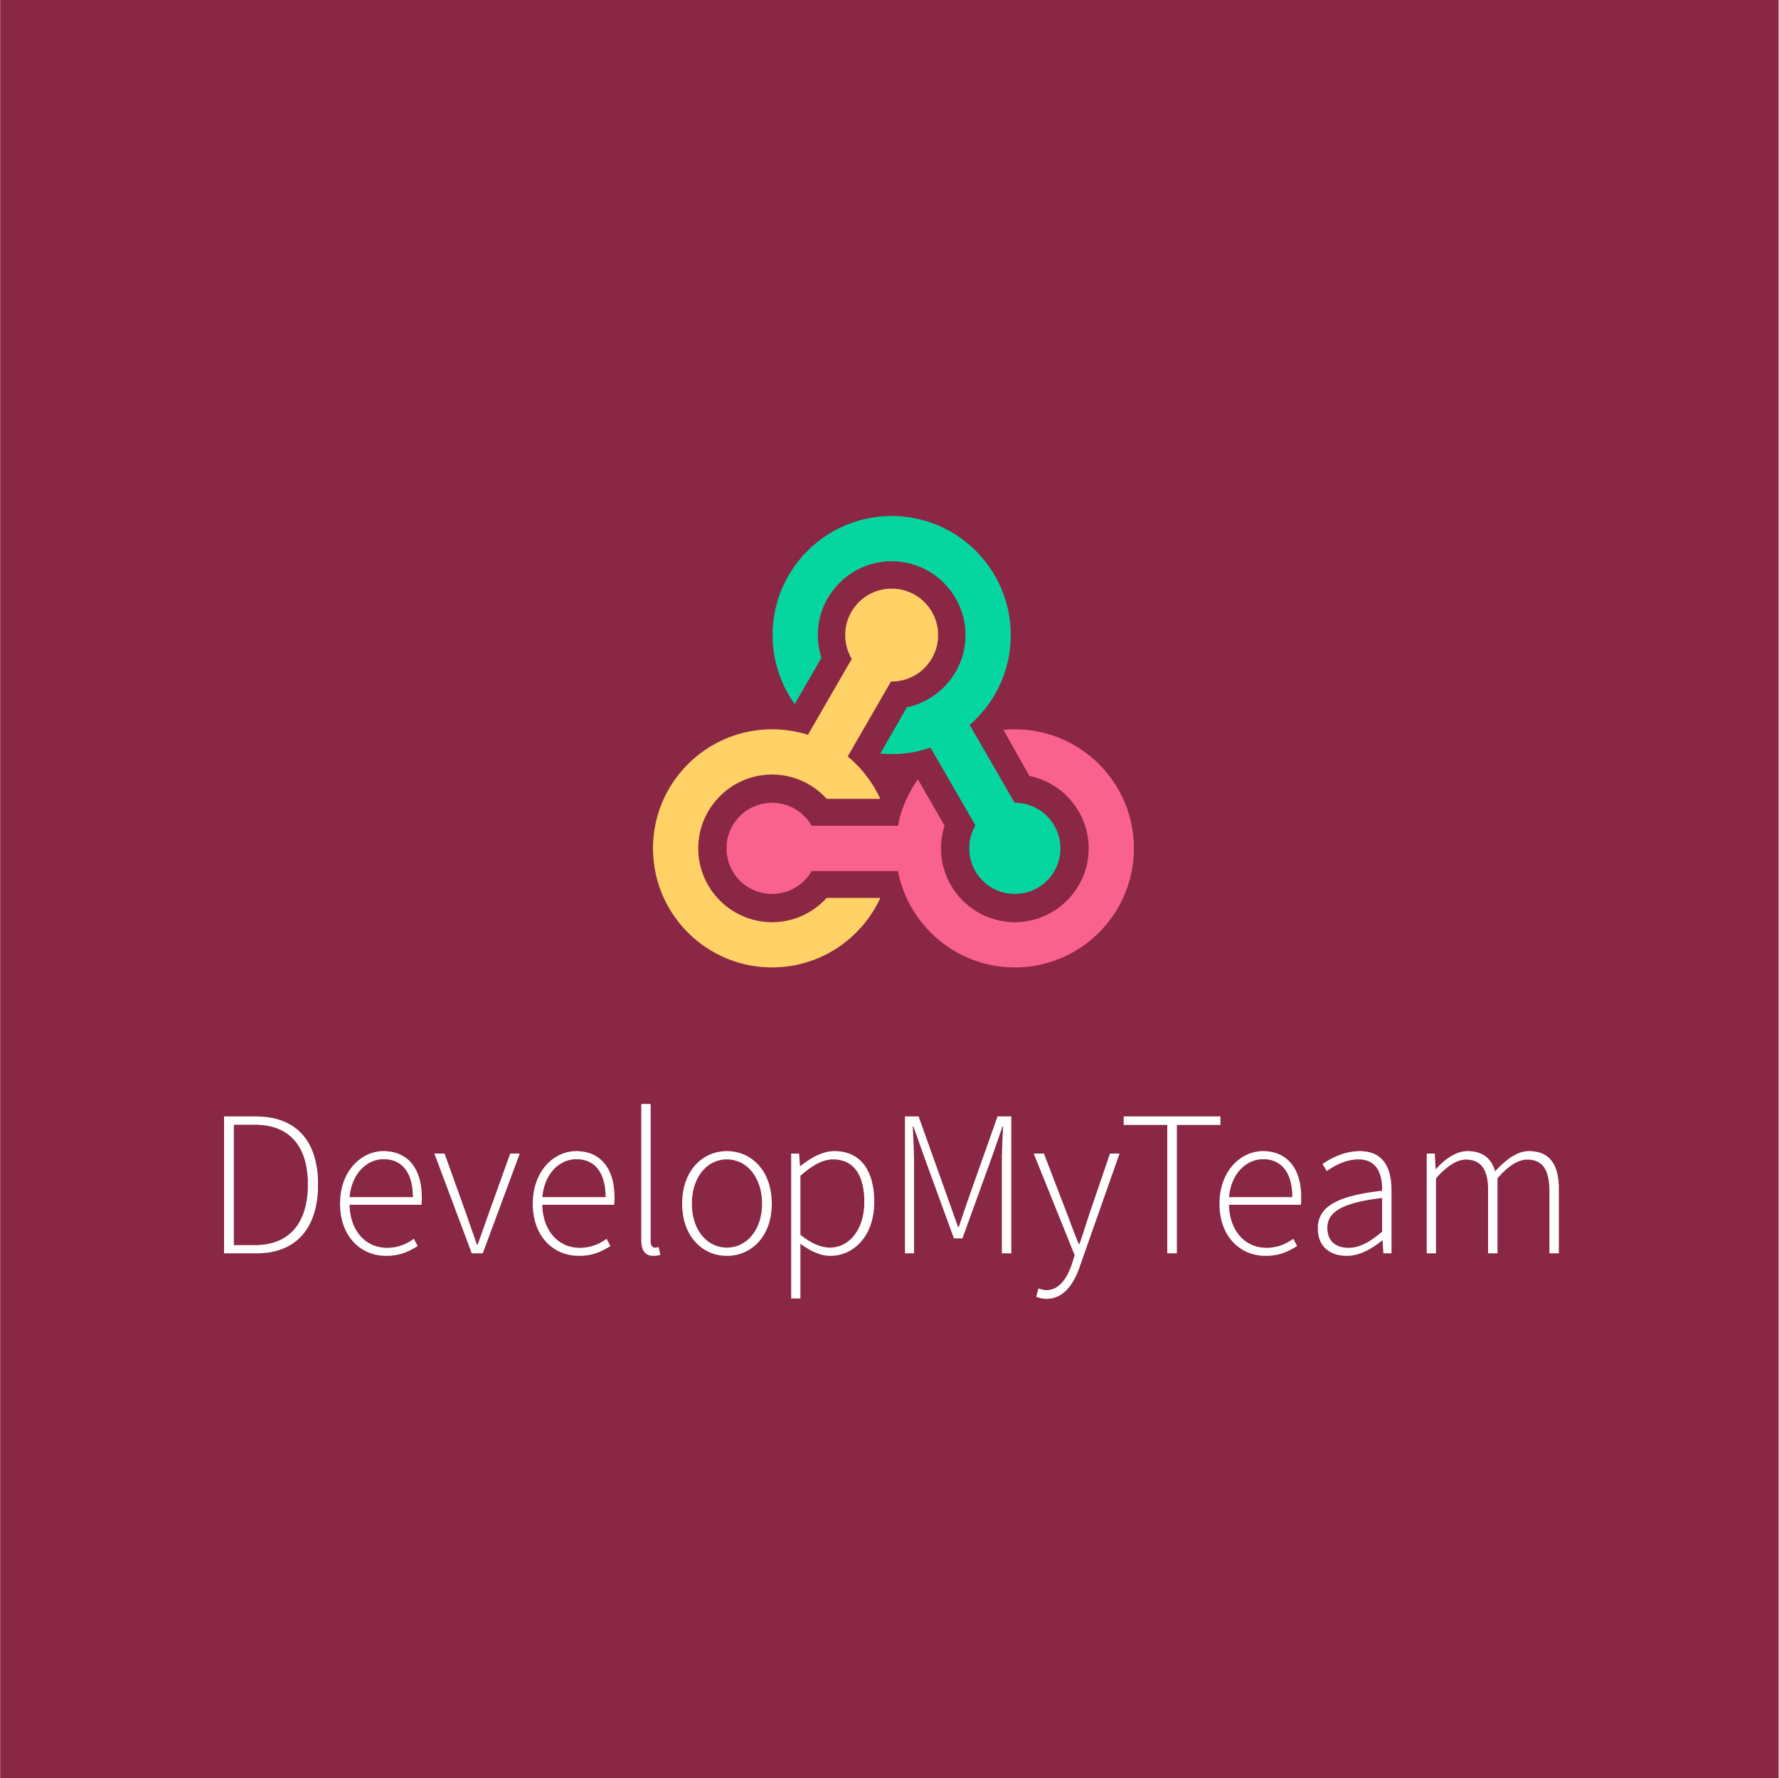

Finance in L&D - How to plan and negotiate that will get your budget'.

Nick Ralphs founder of DevelopMyTeam, the skills assessment platform, shares his views on planning to succeed when securing L&D budget.

According to the CIPD LEARNING AND SKILLS AT WORK 2020 report, whilst 22% of organisations have an L&D budget of +£750 per employee over a third have less than £150 per employee.
https://www.cipd.co.uk/knowledge/strategy/development/learning-skills-work#gref

There is also real uncertainty as to where L&D budgets are likely to go in the short term.
A recent LinkedIn survey showed that “at the beginning of 2020, 37% of L&D professionals expected their budgets to grow, but given pandemic and economic uncertainties that number tumbled to 22% in the middle of the year. Now that we are settling into the new world of work, 33% now report that they expect their budgets to increase.

So even if there is a pot of money for L&D activities you can be sure that accessing that pot is going to be a competitive business. This makes it important that L&D practitioners along with their colleagues in the business spend time preparing for the conversations needed to obtain budget for the activities that will make a difference to business performance.

A background in procurement means I have authored, presented and obtained sign off for a large number of business cases. I’ve also worked closely with L&D practitioners to obtain funds for L&D initiatives. The principles that will improve the likelihood of approval are very similar.

Business Case – You may have lots of supporting slides but ultimately you should be able to sum up the proposition in a maximum of 2 pages. Simple and clear. A structure that will work well in any circumstance is ;

- What are you proposing?
- Who For?
- Why?
- Third Parties – confirm any suppliers involved and how they were selected
- Financials – forecast spend vs. budget

Stakeholder Management

Understand who will ultimately approve the spend and their preferred method of communication. If the case gets signed off in a committee look for a few minutes 1-1 time with the key Executive so they know exactly what you are proposing.

Business Alignment

What is driving the business agenda ? According to the CIPD report achieving growth, improving customer experience and improving culture / reducing costs are currently the big business drivers.
If that’s the case in your organisation and you present a case without clearly linking the outcomes of the activity you need funding for to one of these drivers your chances of approval are limited.

Know The Detail – you need to think through all potential challenge. Can you clearly articulate the problem, how you identified the L&D need, the solution, why the solution will help solve the problem etc

Case studies – Can you show how similar organisations have used the proposed solution to help them to increase engagement, productivity, customer service, -- link to your business drivers

Contingency – If you follow this advice and are well prepared your chance of obtaining sign off will be significantly higher than they would be if you took a winging it approach. However obtaining L&D funding can be a competitive area so consider a contingency plan.

There is no specific mention of negotiation here because the art of negotiation in this internal situation is to plan well and to be well prepared. You need to articulate the case in the best possible way. Ultimately this is binary – you will either obtain approval or you won’t. If there are third party suppliers involved of course there will have been a commercial negotiation involved. That would require a whole new article.

Nick Ralphs

DevelopMyTeam is an on line maturity assessment platform providing Team and Individual based assessments. Our reports provide deep insights that support effective development planning for teams and individuals
https://www.developmyteam.com/

Nick Ralphs is a procurement and supply chain consultant who has worked with Manufacturing and Financial Services organisations in setting up procurement functions, designing policies and process and delivering significant benefits.
https://www.linkedin.com/feed/

